**REPORT OOP LAB 5**

**Họ và tên**: Bùi Quốc Bảo

**MSSV**:20225601

**Mã lớp**: 744520

1. Swing component

* AWTAccumulator

* SwingAccumulator

* Number Grid

1. GUI cho Swing

* StoreScreen:

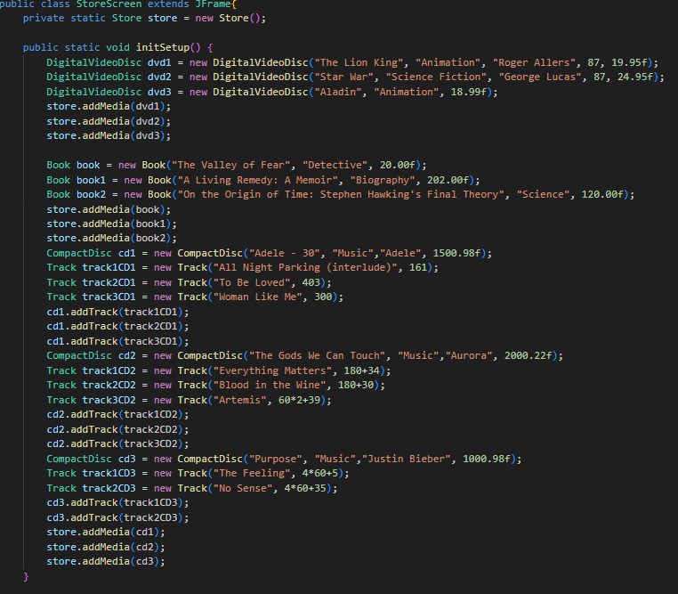

* MediaStore

* Kết hợp MediaStore và StoreScreen

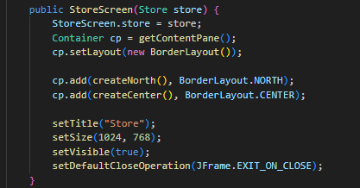

1. JavaFx API

* PainterController

* Painter để chạy ứng dụng

* Màn hình Painter.fxml

1. Xây dựng CartScreen

* Cart Screen

* Tạo CartScreenController xử lý CartScreen

1. Hoàn thành ứng dụng GUI

Tạo ra các lớp Add để hoàn thành

* AddBook

* AddDigitalVideoDisc

* Add CompactDisc

* AddTrack

1. Xử lý Exception

* Tạo PlayerException:

* Sau đó raise Exception

1. Sơ đồ usecase

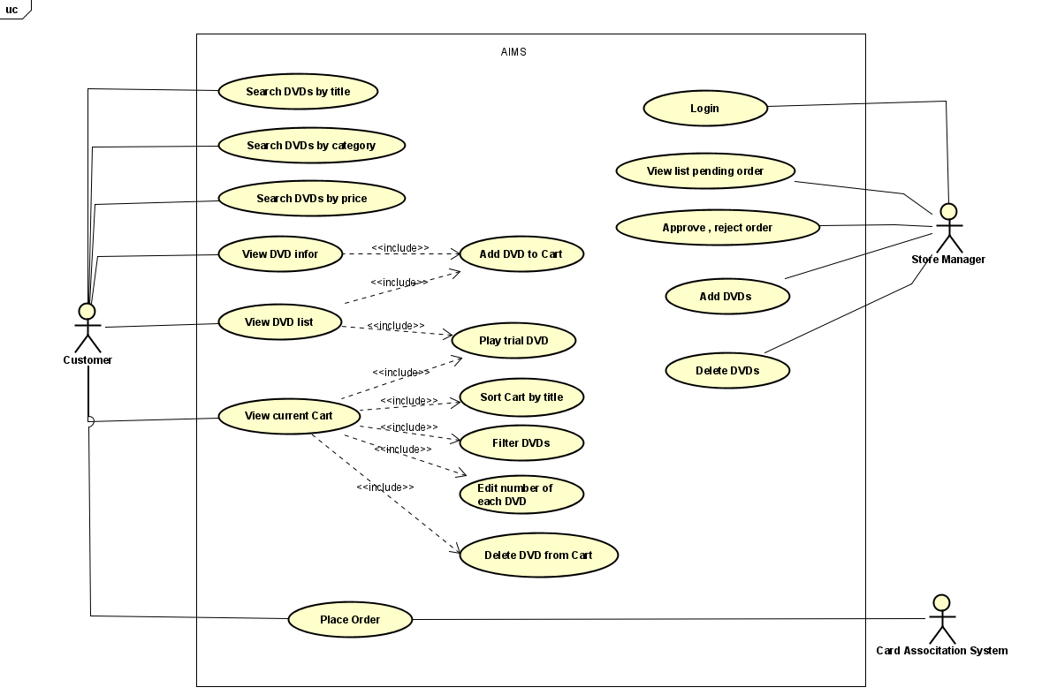

1. Sơ đồ lớp

